Administrative Unit Program Review Template

AU Full Official Name
Campus |  |  |  | AU Review Submission Date
Completed by |  |  |  | AU Review Cycle
Supervisor |  |  |  | Date submitted to Supervisor
Institutional Mission and Goals
The Institutional Mission, Vision, Core Values, and Goals drive all college’s activities. Describe how your unit supports each of these.
Institutional Mission  The College of Micronesia-FSM is a learner-centered institution of higher education that is committed to the success of the Federated States of Micronesia by providing academic and career & technical educational programs characterized by continuous improvement and best practices. |  |  | How the unit supports the mission  Note: In your program review, use a minimum size 10 font for readability. The COM-FSM Publications Manual (item 4) allows for the use of Arial, Calibri, Cambria, and Garamond fonts only for college publications. So select from these fonts only. Complete manual found here.
Institutional Vision  We provide quality education today for a successful tomorrow. |  |  | How the unit supports the vision
Institutional Core Values  Community  - Commitment  - Excellence  - Learner-Centeredness  - Professionalism  - Teamwork |  |  | How the unit supports the Core Values and principles of best practice:  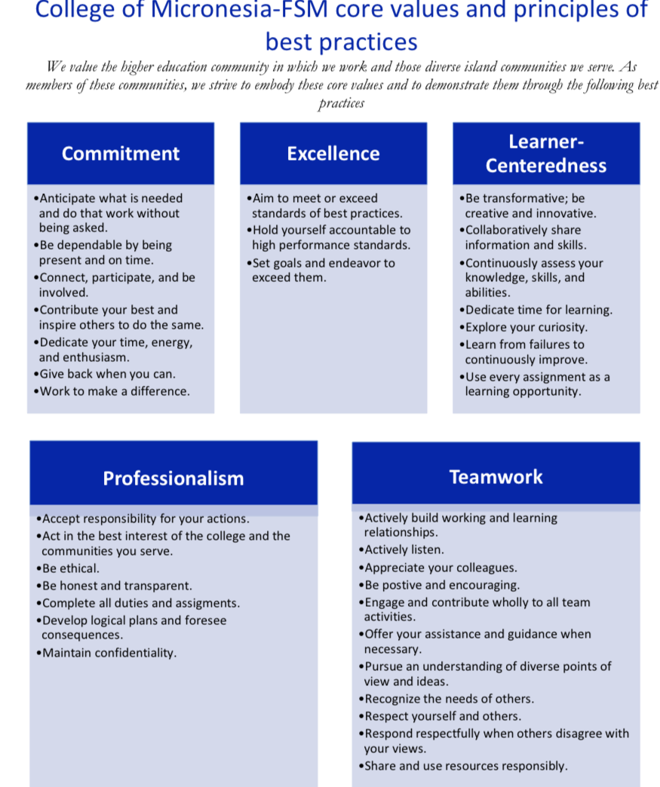
Institutional Strategic Directions  I. Innovate academic quality to ensure student success  Ensure student success by decreasing time to completion and increasing student satisfaction, persistence, retention, and graduation rates by innovating academic quality and enhancing student support services.  II. Strengthen resources to meet current and future needs  Strengthen resources to meet current and future needs through revenue diversification, efficient use, innovation, effective allocation, conservation, infrastructure upgrades, and investment in human capital. |  |  | How the unit supports the strategic directions and measures of success
AU Mission, Goals, and Objectives
Mission Statement |  |  | Goals  Note: Be sure, through goals and objectives that it is clear how this AU serves the college. |  |  |  | Objectives
AU Description, Data and Trends Analysis
Describe the purpose, components, and staffing of the AU
Current Staffing. Complete the table
List each position by classification |  |  | Percent of  Employment |  | Months per Year of  Employment |  |  | Source of Funding |  |  | FTE
Use position titles only, not employee names
Other Resources. Complete the table
List each position by classification |  |  | Services Provided |  |  | Number of Hours |  | Overall Cost |  | Source of Funding
Utilize the data provided in the above table in a discussion of the appropriateness of the staffing levels of the AU

Since the previous AU program review, what significant changes have occurred that impact the services of the AU?
Evaluation of Progress toward previous Goals
List the goals from AU’s previous program review & describe success towards goal achievement.
Goals from previous AU Program Review |  |  |  | Level of Success Achieved
In cases where resources were allocated toward goals, evaluate the efficacy of that spending
Goals from previous AU Program Review |  | Resources Allocated |  |  |  | Efficacy of Spending
Additionally, use the table below to discuss previous recommendations and the resulting changes/actions taken and improvements that have resulted. In other words, provide examples of how this AU program review process has led to continuous quality improvement. If this AU provides services, the discussion should include how assessment of service area outcomes had led to improvements.
Previous Program Review Recommendations |  |  |  | Resulting Changes/Actions
What methods are used to evaluate  AU’s effectiveness to the population  that interacts with it? |  | What do the results of the above  methods of evaluation indicate about  the effectiveness of the AU? |  |  |  | How have the results of this analysis  been used to make improvements to  services provided by the AU?
Provide any other relevant data that are relevant to this AU program review
Strengths, Weaknesses, Opportunities, Challenges (SWOC)
Based on analysis in the preceding
sections, what are the AU’s strengths?
Based on analysis in the preceding
sections, what are the AU’s weaknesses?
Based on analysis in the preceding
sections, what opportunities existing for the AU?
Based on analysis in the preceding
sections, what challenges exist for the AU?
Evaluation of Processes used by AU
Describe any on-going systematic method(s) used to evaluate the efficacy of processes used by the AU.
Service Area Outcomes Assessment
List AU’s Service Area Outcomes by completing the expandable table below
Service Area Outcomes |  |  | Date Assessment  Completed |  | Date(s) Data  Analyzed |  | Date(s) Data Used  for Improvement | Number of Cycle  Completed
Note: for brevity and to save time, hyperlinks to TracDat reports may instead be inserted here, or they may be added as appendices.
AU Assessment. Complete the expandable table
Outcome  Numbers | Intended Outcomes |  | Means of Assessment |  | Criteria for  Success |  | Summary of Data  Collected | Use of Results
 | Note: for brevity and to save time, hyperlinks to TracDat reports may instead be inserted here, or they may be added as appendices.
What challenges remain to make the AU more effective?

Short-Term and Long-Term Goals
Using the table below, list the short and long term goals (a minimum of two for each) for the AU. These goals should follow logically from the information provided in the program review. Use a separate table for each additional goal
Short-Term Goal 1 (Two-Year Cycle)
Identify Goal
Describe the plan to achieve the goal
(i.e., action plan)
What measurable outcome is
anticipated for this goal?
What specific aspects of this goal can
be accomplished without additional
financial resources?
Short-Term Goal 2 (Two-Year Cycle)
Identify Goal
Describe the plan to achieve the goal
(i.e., action plan)
What measurable outcome is
anticipated for this goal?
What specific aspects of this goal can
be accomplished without additional financial resources?
Long-Term Goal 1 (Four-Year Cycle)
Identify Goal
Describe the plan to achieve the goal
(i.e., action plan)
What measurable outcome is anticipated for this goal?
What specific aspects of this goal can
be accomplished without additional
financial resources?
Long-Term Goal 2 (Four-Year Cycle)
Identify Goal
Describe the plan to achieve the goal
(i.e., action plan)
What measurable outcome is
anticipated for this goal?
What specific aspects of this goal can
be accomplished without additional financial resources?
Requests for Resources
Complete a new table for each short-term and long-term goals listed in the immediately preceding section that would require additional financial resources. These requests for resources must follow logically from the information provided in this AU program review.
o Short-Term Goal o Long-Term Goal
Goal Number and Goal Description
Type of Resources | Requested Dollar Amount |  | Potential Funding Source

o Short-Term Goal o Long-Term Goal
Goal Number and Goal Description
Type of Resources | Requested Dollar Amount |  | Potential Funding Source
o Short-Term Goal o Long-Term Goal
Goal Number and Goal Description
Type of Resources | Requested Dollar Amount |  | Potential Funding Source
o Short-Term Goal o Long-Term Goal
Goal Number and Goal Description
Type of Resources | Requested Dollar Amount |  | Potential Funding Source
AU Program Review Summary
This section provides the reader with a brief overview of the highlights, themes, and key segments of the AU program review.

Note: This should be a concise summary of improvements, key areas of focus (goals) moving forward, and a summary of resources needed to achieve those goals (human, financial, physical, technological). Because the details should have been discussed above, the summary is to be a maximum of 500 words.

