COLLEGE OF MICRONESIA-FSM
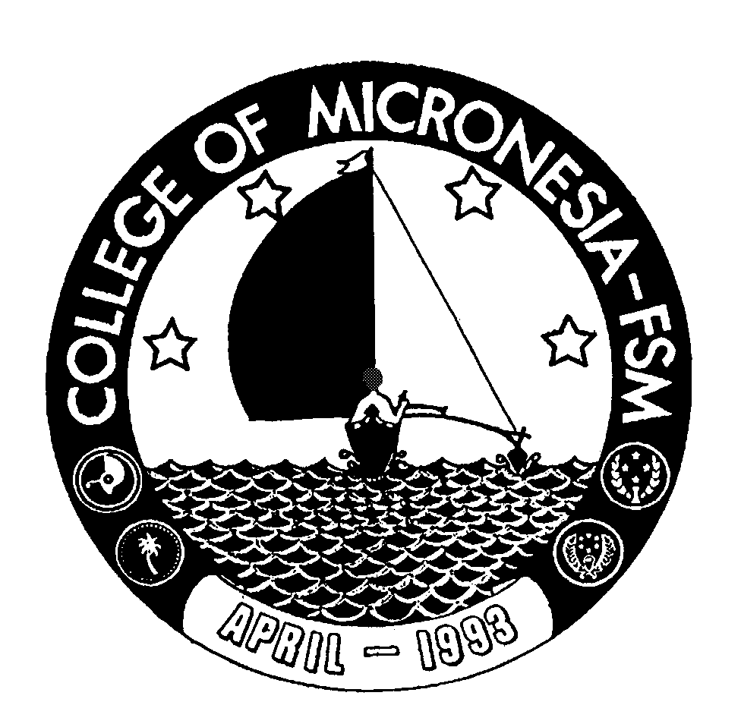
P. O. Box 159
Kolonia, Pohnpei FM 96941

Associate of Arts
in
TEACHER PREPARATION

_____________________________________ ___________________________
Name State/Republic

Date of First Test |  | Placement Test
 | English  Listening/Speaking |  | English  Structure | English  Reading | English  Total | Math

GENERAL EDUCATION CORE REQUIREMENTS |  |  |  |  |  |  |  |  |  |  |  | MAJOR REQUIREMENTS (41 credits)
English (9 credits)
EN 110 Advanced Reading |  |  | 3____ |  |  |  |  |  |  | AR 101 Intro. To Art |  |  |  |  |  | 3____
EN 120a Expository Writing I |  |  | 3____ |  |  |  |  |  |  | SS/PY 101 General Psychology |  |  |  |  |  | 3____
EN 120b Expository Writing II |  |  | 3____ |  |  |  |  |  |  | SS 120 Introduction to Geography |  |  |  |  |  | 3____
 |  |  |  |  |  |  |  |  |  | SS 125 or SS 170 or SS 171 |  |  |  |  |  | 3____
 |  |  |  |  |  |  |  |  |  | EN 208 Intro. to Philosophy |  |  |  |  |  | 3____
Mathematics (3 credits) |  |  |  |  |  |  |  |  |  | EN 200 series from: EN 201, EN 205, or
Any 100 level or above Mathematic |  |  |  | 3______ |  |  |  |  |  | EN 233a |  |  |  |  |  | 3____
course (recommended MS 100 or MS 101 or MS |  |  |  |  |  |  |  |  |  |  | EN/CO 205 Speech Communication |  |  |  | 3____
 | Natural Sciences (7 credits) |  |  |  |  |  |  |  |  |  | MS/ED 210a Math for Teachers |  |  |  | 3____
 | A science course with lab and |  |  |  | 4____ |  |  |  |  |  | Science w/Lab |  |  |  | 4____
 | Non-lab science from: SC 101, SC 112, ESS/SC 200 or SC/SS 115 |  |  |  | 3____ |  |  |  |  |  | ED 210a Intro to Professional Teaching |  |  |  | 4____
 |  |  |  |  |  |  |  |  |  |  | ED/PY 201 Human Growth and
 | Social Sciences (3 credits) |  |  |  |  |  |  |  |  |  | Development |  |  |  | 3____
 | SS 150 History of Micronesia |  |  |  | 3____ |  |  |  |  |  | ED 215 Intro. to Exceptional Children |  |  |  | 3____
 |  |  |  |  |  |  |  |  |  |  | ED 292 Practicum |  |  |  |  | 3____
 | Computer Application (3 credits)
 | CA 100 Computer Literacy |  |  |  | 3____
 | Exercise Sports Science (1 credit)
 | Choice of any ESS course |  |  |  | 1____
 | Humanities (3 credits)
 | Any course in art, music, history,
 | Literature, philosophy or language |  |  |  | 3____
 | (MU 101 recommended) |  |  |  |  |  |  |  |  |  | Total Graduation Requirements |  |  | 70 credits

